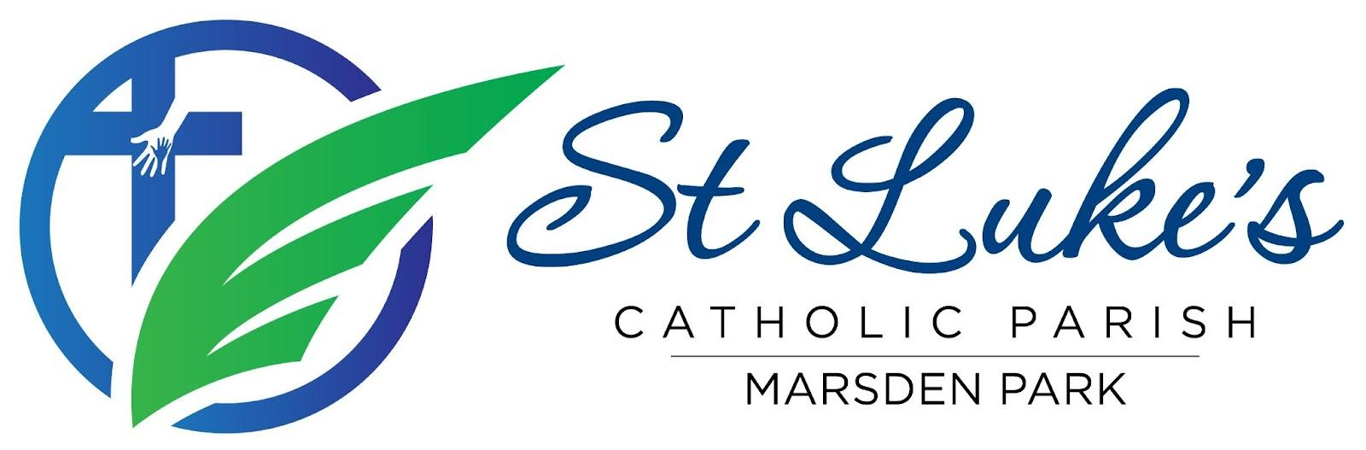
Parish Pastoral Council (PPC) Meeting Minutes – 2026
Date/time/venue: 18 April 2026, 6:45–8:30 PM (following Vigil Mass), St Luke’s Catholic College
Meeting closed: 8:54 PM
Attendees: Fr Gayan Thamel (GT), Aleta Dela Cruz (ADC), Malinda Fernando (MaF), James Irudayaraj (JI), Chrissy Presello (CP), Jerome Semau-Roache (JSR), Geraldine Santos (GS), Alistair Soares (AS)
Apologies: Mandy Goswami (MG), Ramon Gunasekera (RG), Kelly Bauer (KB), Althea Dela Cruz (ADC2), Perpetua Oninye (PO)
Ex-Officio: Ged Oblea (GO), Tessie James (TJ)

1. Fellowship Dinner
The meeting began with a shared meal, strengthening fellowship within the Council.

2. Opening Prayer
Opening prayer led by GO.

3. Check-in
Members shared brief updates and reflections.

4. For Noting: External / Subcommittee / Ministry Updates
Diocese
- Plans are underway for an interfaith event marking the Assisi gathering for peace.
- Next year’s Iftar will include representation from our parish community.
Deanery / College
- No major updates this month.
Building & Facilities
- A new parish noticeboard has been installed.
- Outdoor lighting is now operational and will be adjusted for winter.
Fundraising
- The Weekend Food Stall continues—thank you for your support.
- Planning has commenced for the Parish Dinner Dance.
- We are currently seeking a Fundraising Lead.
Social Media
- Parishioners engage most with event highlights and celebrations.
- Suggestions include sharing more about saints and daily Gospel links.
Safeguarding
- Our parish will undergo a Safeguarding Audit in June.
- Volunteers are reminded to complete required safeguarding training.
- The Parish Volunteer Register will be updated in the coming weeks.
Parish Life & Operations
- Holy Week, Easter, Divine Mercy Sunday, and our 8th Parish Anniversary were celebrated with strong community participation.
- Pastoral Care Ministry continues to support parishioners at home and in aged care.
- Ministry Recruitment Drive scheduled for Pentecost weekend (23–24 May).
- Updates to parish finances and leadership within the Finance Committee were noted.
Sacraments
- Reconciliation: 34
- First Holy Communion: 86
- Confirmation: 51

5. Vox Populi (Community Feedback)
- Feedback received that the church was very warm during the recent 10 AM Mass.
- This will be considered in planning future events.

6. Census Data Entry Progress
- 209 census responses received so far—thank you to all who participated.
Key insights:
- Our parish reflects a rich multicultural community.
- 46% of respondents are not currently involved in a ministry.
- Exploring improved (digital) methods for future data collection.

7. For Discussion/Update: Pastoral Plan 2026–2028
- Work continues on shaping the Parish Pastoral Plan to guide our future direction.
- PPC members will provide further input in the coming weeks.

8. Role Vacancies
- Fundraising Lead role currently vacant.
- PPC membership- requirements from upcoming term discussed.
- MG will continue as Executive Secretary until the end of the year.
- Transition to a new Executive Team structure is underway.

9. For Noting: Roster for PC Visibility
- Noted.

10. For Noting: Upcoming Events
- 23–24 May: Pentecost & Ministry Recruitment Drive
- 1–5 June: First Holy Communion Masses
- 8 June – 8 July: Fr Gayan on Annual Leave
- 20 June: PPC End of Term
- 25 July: Parish Dinner Dance

11. Confirmation of Actions & Message to the Community
- Ongoing actions reviewed.
Message to our parish community:
We warmly invite all parishioners to get involved in the life of the parish, especially through the upcoming Ministry Recruitment Drive. Your participation helps our community continue to grow in faith and service.

12. Meeting Close and Closing Prayer
Meeting concluded with prayer led by CP.

Next Meeting
Proposed: 16 May 2026

