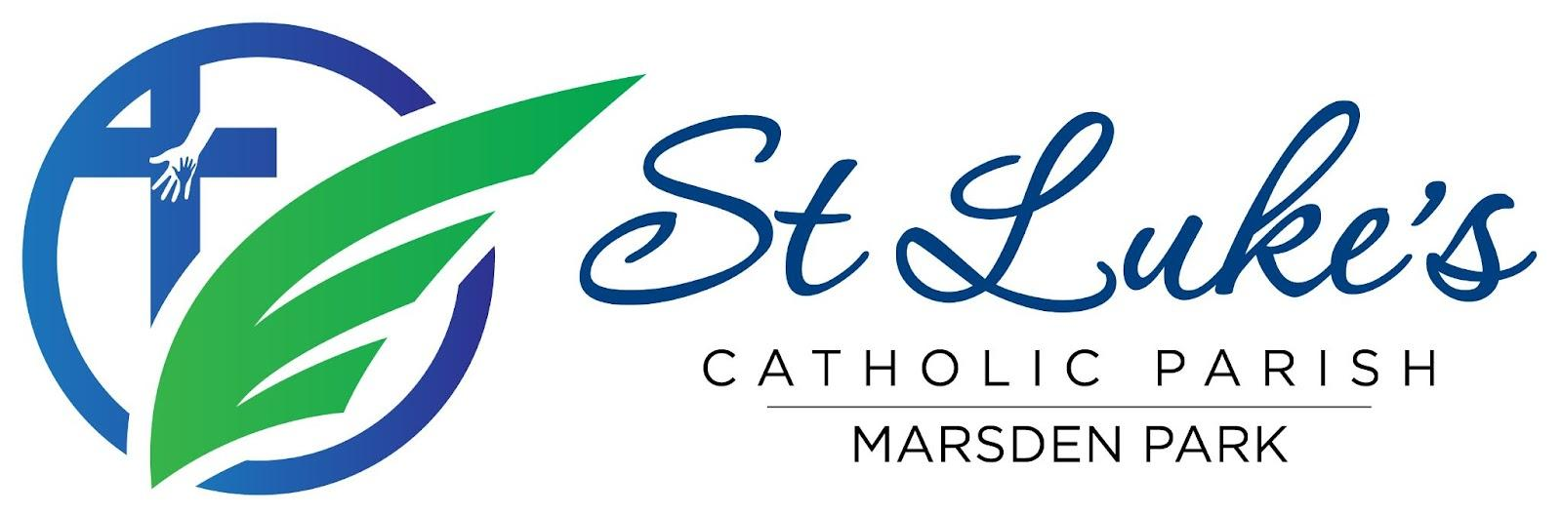
Agenda: Parish Pastoral Council 2026 Meeting
Date/time/venue: 18 July 2026, 7.00 - 8:30 PM, following the Vigil Mass at St Luke’s Catholic College
Attendees: Fr Gayan Thamel (GT), Malinda Fernando (MF), Mandy Goswami (MG), Ramon Gunasekera (RG), Chrissy Presello (CP), Jerome Semau-Roache (JSR), Alistair Soares (AS), Ged Oblea (GO), Didi Surian (DS), Christine Leahy (CL), Caroline Tuli (CT), Rex D’Abreu (RD)
Ex-Officio: Kelly Bauer (KB), Ged Oblea (GO)
Apologies: Althea Dela Cruz (ADC2), Kelly Bauer (KB), Perpetua Oninye (PO)

1. Fellowship Dinner
The meeting commenced with fellowship and dinner shared amongst PPC members.

2. Opening Prayer
Opening prayer led by Alistair Soares.

3. Check-in
Members participated in a brief check-in and community sharing.

4. Confirmation of Previous Minutes
Seconded by Jerome Semau-Roache.

5. Ministry and Parish Updates

Diocese / Deanery
- No updates.

College
- Kelly will be away during weeks 7-9.

Building and Facilities
- New screens have been installed in the office area to help keep parishioners attending the weekend Masses warm and protected during the winter months.

Fundraising
- Preparations for the 2026 Dinner Dance are progressing well, with over 140 tickets confirmed sold.
- Sponsorships are expected to cover all costs for the event, with ticket sales bringing in profit.
Children’s Liturgy (CLOW)
- Children’s liturgy currently on a break due to School Holidays.
- Feedback from the new Onboarding module was positive.
- Recent Safeguarding Audit preparation meeting offered valuable insights on enhancing our sound safeguarding practices.
Finance
- Financial Audit scheduled for 11th September, with an update to follow to all Parishioners.
Social Media
- Upcoming meeting on 29th July to discuss the Parish Social Media Strategy.

Safeguarding
- Safeguarding Audit was successful with the final report to be shared in August.
- Work is underway to update safeguarding and training records.

Parish Operations
- Weekday and weekend Masses continue to be celebrated.
- First Reconciliation Program is underway, with the celebration to be held on Wednesday, 12th August.
- Children aged 7 years and above are being prepared for Baptism.
- Holy Communion continues to be taken to the sick and homebound.
- The Pastoral Care Team is continuing its ministry of visiting and supporting residents at the nursing home in Marsden Park.
- Alter Servers training has been completed.
- The Recruitment Ministry Drive is continuing to drive new volunteer memberships in various ministries.
- Ongoing maintenance and administration continue to support the needs of the Parish Community.

Youth Ministry
- No updates.

6. Vox Populi (Community Feedback)
- Suggestions were provided for ways to reduce disruptions during Mass.
- Discussed the availability of PPC support to Ministry Leads as required and enhancing ways of working.

7. PPC Updates
- Four new PPC members were officially welcomed by Father Gayan.

8. Parish Pastoral Plan 2025–2027
- The Parish Pastoral Plan was introduced to new PPC members.
- PPC members to review Parish Pastoral Plan and provide feedback by 28th July.

9. Diocesan Meeting
- Diocesan meeting was held at Mary Immaculate, Quakers Hill on Wednesday 24th June 6.30PM to 8.30PM.
- The six priorities were explored within our own and with other Parish groups:
  - An inclusive and welcoming Church
  - A humble and healing Church
  - A listening Church
  - A Church renewed in Spirit and Prayer
  - A Church that reaches to the margins
  - A Church walking together

10. Other Business

Working groups were formed for the following events:
- St Luke’s Feast Day (18th October)
- Parish Pilgrimage (14th November)
- Volunteer Christmas Party (28 November)

11. Upcoming Parish Events
- 25 July: Dinner Dance 2026
- 12 August: First Reconciliation
- 15 August: Assumption Masses
- 6 September: Father’s Day
- 11 & 18 September: Confirmation Masses
- 10 & 11 October: Financial Update
- 18 October: St Luke’s Feast Day
- 7 November: Formation Day
- 14 November: Parish Pilgrimage
- 28 November: Volunteer Christmas Party
- 4 December: St Luke’s Community Christmas Carols

12. Meeting Close
The meeting concluded with prayer and thanks to all members, ministry leaders, volunteers, and parishioners for their continued service and commitment to the parish community.

