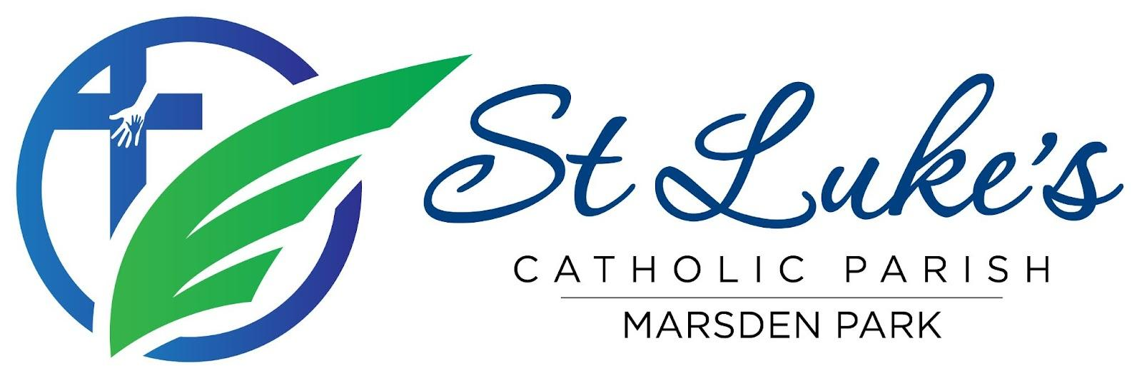
Agenda: Parish Pastoral Council 2026 Meeting
Date/time/venue: 15 August 2026, 7.00 - 8:30 PM, following the Vigil Mass at St Luke’s Catholic College
Attendees: Fr Gayan Thamel (GT), Malinda Fernando (MF), Mandy Goswami (MG), Ramon Gunasekera (RG), Jerome Semau-Roache (JSR), Alistair Soares (AS), Ged Oblea (GO), Didi Surian (DS), Rex D’Abreu (RD), Kelly Bauer (KB)
Ex-Officio: Kelly Bauer (KB), Ged Oblea (GO)
Apologies: Althea Dela Cruz (ADC2), Chrissy Presello (CP), Christine Leahy (CL), Caroline Tuli (CT), Perpetua Oninye (PO).

1. Fellowship Dinner
The meeting commenced with fellowship and dinner shared amongst PPC members.

2. Opening Prayer
Opening prayer led by Father Gayan Thamel.

3. Check-in
Members participated in a brief check-in and community sharing.

4. Confirmation of Previous Minutes
Seconded by Kelly Bauer.

5. Ministry and Parish Updates

Diocese / Deanery
- Upcoming meeting on Saturday, 29th August at Mary Immaculate, Quakers Hill.

College
- Kelly will be away during weeks 7-9.
- Hall will be unavailable for the first 5 weeks of Term 4 due to HSC.

Building and Facilities
- A new speaker has been installed outside, and a TV for live-streaming Mass has been installed on the wall outside the parish office.
Children’s Liturgy (CLOW)
- Steady attendance numbers at Children’s liturgy
- Upcoming workshop for volunteers to be held on Sunday, 30th August 11.30AM.
- New dismissal process being trialled.
Social Media
- New strategy to be implemented with the launch of Parish App.

Safeguarding
- Work is underway to update safeguarding and training records.

Parish Operations
- Fundraising Dinner Dance successfully held, generating a profit of approximately $20,000.
- 80 children received the Sacrament of Reconciliation on 12 August.
- Confirmation preparation sessions have commenced for 65 candidates, including Commitment Masses.
- The parish is exploring the establishment of a Seniors Group, and parishioners are invited to submit an expression of interest.
- Two new Hospitality ministry leads have been appointed and will be announced at mass.
- The parish is now a recipient of Return and Earn donations to charity.

Youth Ministry
- CYP hosted a World Youth Day launch, sharing pilgrimage costs and eligibility details.

6. Vox Populi (Community Feedback)
- Discussed the set up of BPoint to enable successful direct debit donation payments.
- Discussed whether the parish has a sick bay for parishioners needing rest or experiencing sickness during mass.
- Discussed how to maximise donations during collections.

7. Parish Pastoral Plan 2026–2028
- Discussed launching the Parish Pastoral Plan on weekend of 5th and 6th September during mass, on social media and parish website.

8. Feast Day Planning
- Update was provided on the discussions held during the recent planning meeting.
- Discussed logistics and entertainment ideas for the feast day.

9. Parish App

- The Parish App was demonstrated and received very positive feedback.

10. Other Business

- Correspondence from a Parishioner was discussed and an outcome was agreed.

11. Upcoming Parish Events
- 12 August: First Reconciliation
- 15 August: Assumption Masses
- 6 September: Father’s Day
- 11 September: Confirmation Mass
- 10 & 11 October: Financial Update
- 18 October: St Luke’s Feast Day
- 7 November: Formation Day
- 14 November: Parish Pilgrimage
- 28 November: Volunteer Christmas Party
- 4 December: St Luke’s Community Christmas Carols

12. Meeting Close
The meeting concluded with prayer and thanks to all members, ministry leaders, volunteers, and parishioners for their continued service and commitment to the parish community.

